

THE UNIVERSITY OF AZAD JAMMU AND KASHMIR, MUZAFFARABAD
STUDENT NAME: | SHAHZAD AHMED AWAN
STUDENT ROLL NO: | 2024-SE-15
LAB: | 01
COURSE TITLE: | Computer Networks
COURSE CODE: | CS-2203
INSTRUCTOR: | Engr. Dr. Asma Javaid
SUBMISSION DATE: | 04 March, 2026
Department of Software Engineering

Lab 01: Installation of Cisco Packet Tracer

Introduction
This lab covers the installation and setup of Cisco Packet Tracer, a network simulation tool used for practicing network design and configuration.

Objective
- Install Cisco Packet Tracer.
- Verify successful launch.
- Explore the basic interface.

Tools / Software

Item | Details
Software | Cisco Packet Tracer 8.x
OS | Windows 10/11
PC Specs | 4GB+ RAM, 2GHz+ CPU

Procedure
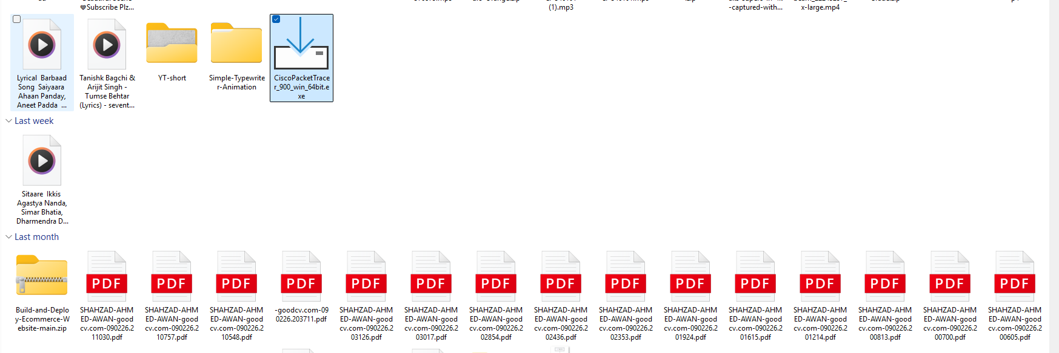
- Download installer from Cisco Networking Academy.
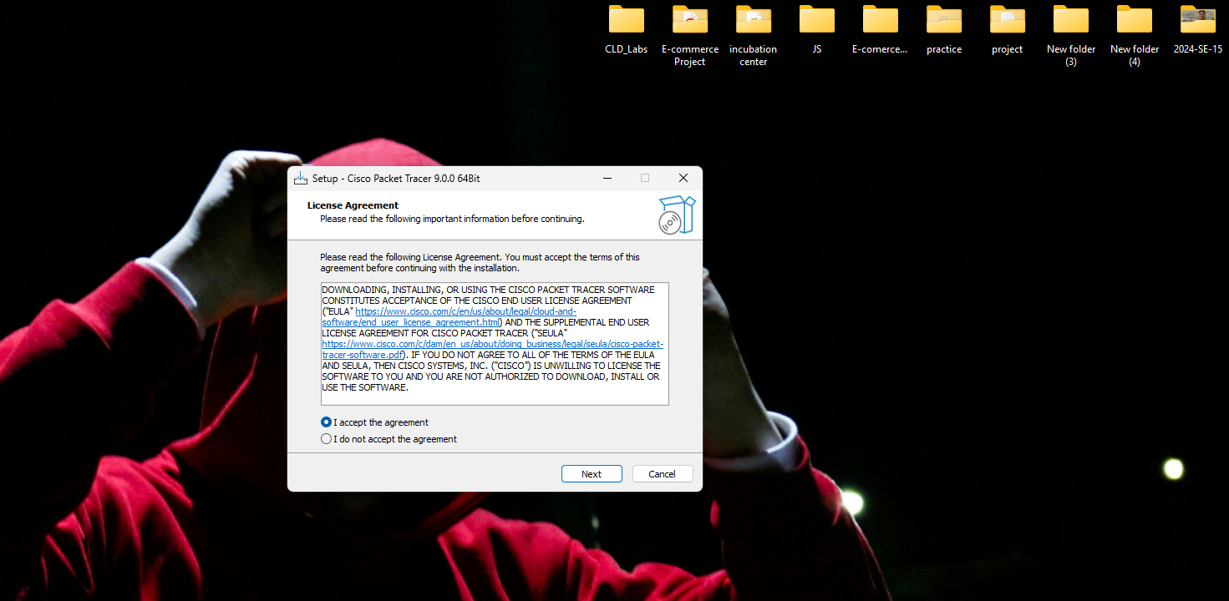
- Run .exe and accept the agreement.

- Select the Destination Location and click install.
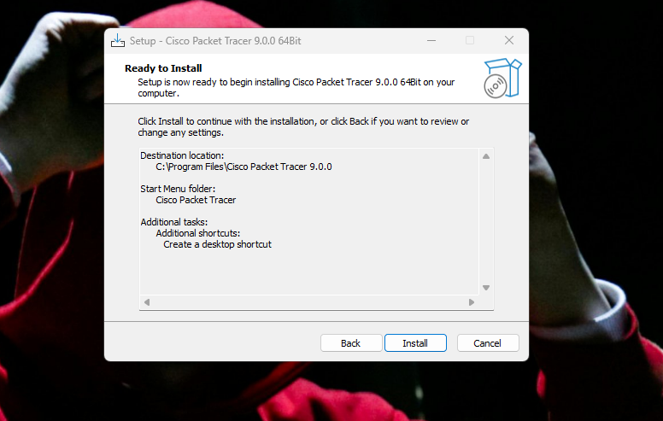
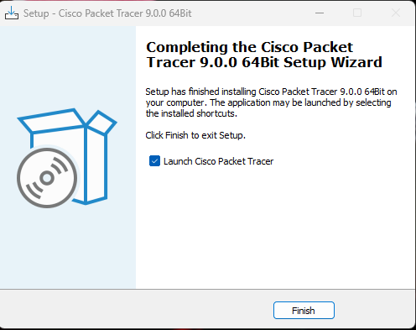
- Click on Finish and Launch the Application.

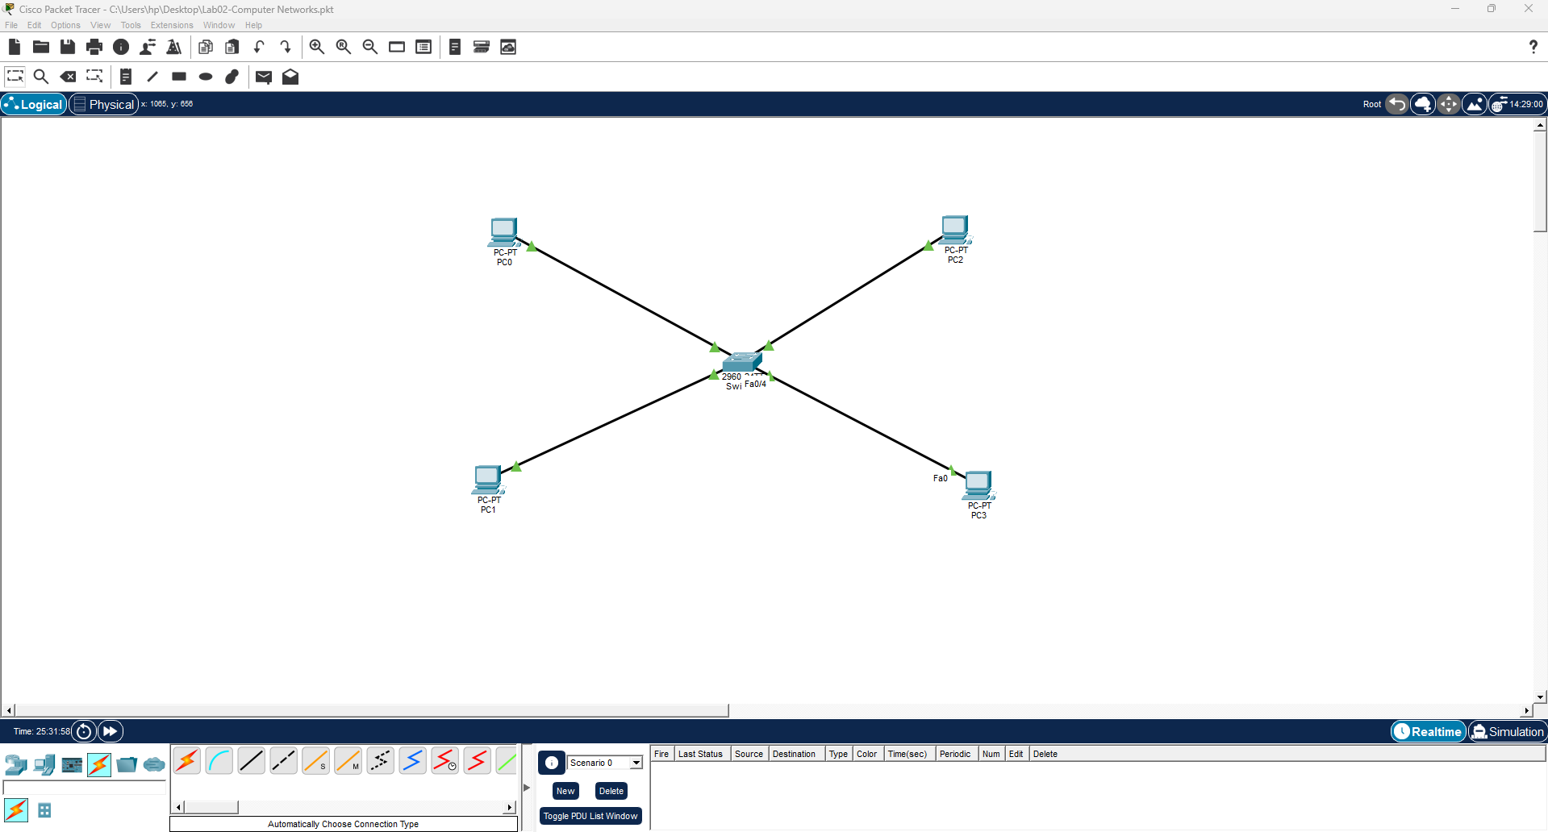
- Explore interface: workspace, device types, toolbar, simulation panel.

Observations
- Installation completed successfully.
- Software launched without errors.
- All devices and tools accessible.

Conclusion
Cisco Packet Tracer installed and ready for use. Interface explored. Prepared for future network simulation labs.

